To marketoperations@ea.govt.nz


Re: FTRs: 4-letter participant identifier application form

Attention: Operations Team

I would like to:
apply for one or more new participant identifiers for trading in FTRs; or
apply for my existing participant identifier/s to be used for trading in FTRs; or
expire my existing participant identifier/s for trading in FTRs.

If you are a wholesale electricity industry participant with access to the electricity registry you should use your existing 4-letter participant identifier for FTR trading. Please fill out this form to apply for the existing identifier to be applied to FTR trading.

If you are new to the electricity industry and wish to trade in FTRs you need to apply for a 4-letter participant identifier using this form.

If you wish to use more than one participant identifier and hold more than one trading position in the FTR market, you must apply to have more than one identifier registered for FTR trading. (Note that in this case, you will be asked by the clearing manager to advise how your corporate prudential status is to be allocated across your trading positions.)

Note that both existing and new electricity industry participants must also be registered with the Authority as an industry participant under the category “trader in electricity”. (FTR participants fit within the definition of “traders in electricity” under the Electricity Industry Act 2010.) Check your industry registration status on the Participant Register http://www.ea.govt.nz/act-code-regs/particpant-register/ and if necessary, fill in the Participant Registration form http://www.ea.govt.nz/our-work/forms/. You may send in both forms at the same time.

Please email the completed form to the above email address to have your request considered by the Authority.

- Participant details (To be completed by the company’s primary FTR contact person)

Name: ___________________________________________________________

Position: ___________________________________________________________

Company: ___________________________________________________________
(note: this is the organisation applying to be an FTR participant, not an agent’s organisation)
Telephone: ___________________________________________________________

Email address: ___________________________________________________________

Signature: ___________________________________________________________
Date: ___________________________
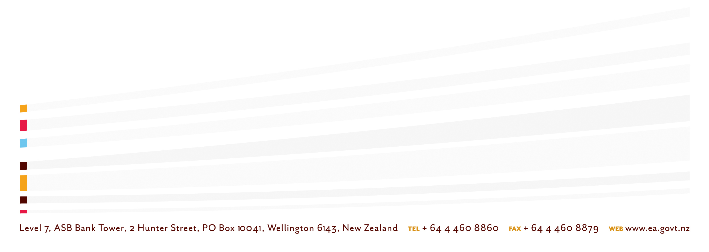
- Reuse existing participant identifier OR Request new participant identifier
Existing participant identifier you wish to use for trading FTRs:    
Existing participant identifier you wish to use for trading FTRs:    

New participant identifier requested :     Start date _____/______/_____
(insert your preferred letters, e.g. the first four letters of your company’s name)
Second new participant identifier requested :     Start date _____/______/_____
Note that new participant identifiers must be used solely for trading in FTRs and not for other electricity market purposes unless you register the identifier with the Authority for that other purpose.

Authority use only
New participant identifier approved?  Yes  No
If no, why not?

- Participant identifier expiry
 I wish to expire the following existing participant identifier completely (for all uses)
OR
 I wish to deregister this participant identifier for FTR trading but keep it for other purposes.
The other purposes are: ___________________________________________________________
_______________________________________________________________________________

Participant identifier:     End date _____/______/_____
Participant identifier:     End date _____/______/_____

Reason for expiry of identifier: ______________________________________________________
_______________________________________________________________________________

Authority use only: Authorisation
Signature:____________________________
Date:________________________________

